**PHYSICS YEAR 12**

**TOPIC TEST: VECTORS & PROJECTILE MOTION**

Name: ________________________________ Weighting: 5% Mark: _________/50

Materials: *Pens/Pencils, Eraser, Ruler, Calculator, Formula Sheet.*

Time: 55 Minutes.

*Give all numerical answers to 3 significant figures (estimation questions to 2 significant figures), unless instructed otherwise in the question.*

1. A 70 kg cyclist (inc. bicycle) rides their bicycle North along a flat, level stretch of road at a constant velocity of 4.50 m s-1, doing work against a 60.0 N friction force.
   1. What is the net force acting upon the cyclist? Justify your response:

(2 marks)

* 1. The cyclist turns to the East with a new constant velocity of 3.50 m s-1. Find the change in velocity:

(4 marks)

1. 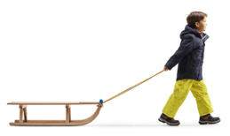A 20.0 kg sled is being pulled at a constant velocity such that the angle that the handle makes with the horizontal is 30˚. A friction force of 40.0 N opposes the motion of the sled.
   1. Find the force applied by the child on the sled.

(2 marks)

* 1. Find the total force that would need to be applied to achieve an acceleration of 2.0 ms-2 with respect to the ground. Assume the angle of the rope and the friction force stays constant.

(3 marks)

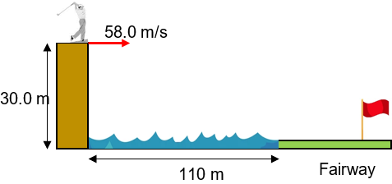

1. At the ‘Extreme Golf’ challenge, one of the courses involves hitting a ball horizontally from the top of a 30 m cliff-face across a 110 m wide lake onto the fairway. One golfer hits the golf-ball with an initial speed of 58.0 m/s.

Determine whether the ball lands on the fairway.

(4 marks)

1. Removalists need to load a 136 kg piano into a truck by placing it on a wheeled trolley and roll it up a ramp. Two of the removalists, each with a mass of 60 kg, need to get onto the ramp to move the piano.

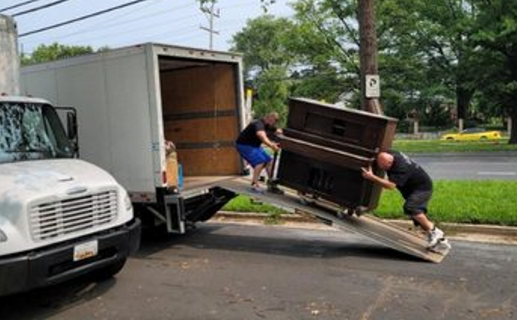

* 1. The ramp will bend significantly and break if the normal reaction exerted by the ramp exceeds 2300 N. Using calculations determine the minimum angle to the horizontal that the ramp can be pitched to move the piano (ignore friction effects).

(4 marks)

* 1. Calculate the minimum force up the ramp that must be exerted by the removalists to load the piano into the truck.

(2 marks)

1. A projectile is launched from a flat piece of land with a speed of 10.0 m s-1.
   1. Find the range if the projectile is launched at 30˚ to the horizontal:

(3 marks)

* 1. What angle, other than 30˚, would achieve the same range for the projectile (assuming the same initial speed)? Justify your response:

(2 marks)

1. Consider the motion-capture image below, taken from the 2018 PyeongChang Winter Olympics ski-jumping event in South Korea. Consider the first position of the ski-jumper to have been taken at time t = 0 seconds, and the angle of the jump to be approximately 70˚ to the horizontal. The maximum height achieved by the ski-jumper (above the first position) measures at 5.62 m.

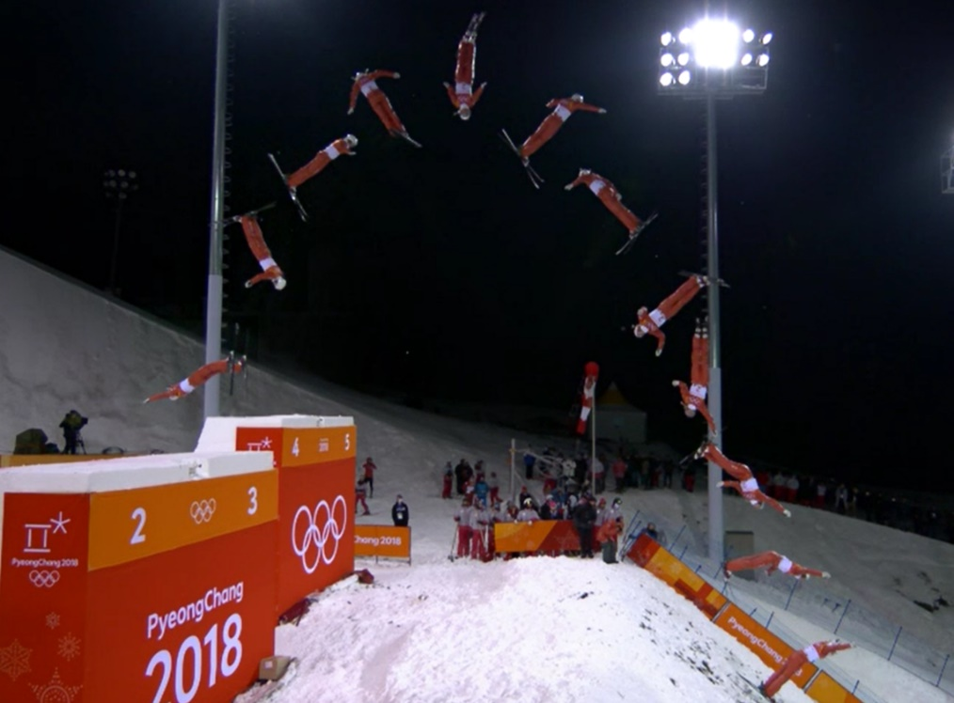

* 1. Find the initial speed of the ski-jumper:

(2 marks)

* 1. Find the time to reach maximum height:

(1 mark)

* 1. Find the frequency of the camera shutter:

(2 marks)

* 1. Find the total time over which the image was taken:

(2 marks)

* 1. Find the range of the jump:

(2 marks)

1. A soccer player kicks a soccer ball with a speed of 22.0 m s-1 at an angle to the horizontal of 31˚. The ball achieves a maximum height of 6.55 m, before hitting an unsuspecting stationary opposing player in the head. By *estimating* the height of the opposing player, calculate how far away he was standing from the kicker when the ball was kicked.

(5 Marks)





6.55 m

22.0 m/s

? m

31˚

1. A team of firefighters aimed their hose to put out a fire in a high-rise building. The fire is 8.10 m above the ground. The water comes out of the hose at a speed of 25 ms-1, and the hose is held at a height of 1.30 m above the ground. The time taken for the water to reach the fire from the hose nozzle is 1.63 s.

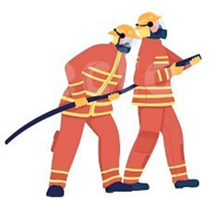



Height of Fire = 8.10 m

1.30 m above ground

θ

25 m/s

Distance from Building

* 1. Find the distance between the firefighters and the base of the building.

(5 marks)

* 1. Find the velocity of the water when it reaches the fire.

(5 marks)

**END OF TEST**